Expression of interest application
Safe Multicultural Out Of School Hours (SMOOSH)

BS C: 7.00am to 8.45am: Fee $12 for the permanent session of 2 hours
(Including breakfast)
ASC: 3.00pm to 6.00pm: Fee $18 for the permanent session of 3 hours
(Including afternoon tea and homework help)
VC: 7.00am to 7.00pm: Fee $46 (plus cost of excursion activity) for 11 hours. Located at
Bankstown Public School.

The fees above are full fees (before the application of the Child Care Subsidy).

If you are entitled to 85% Child Care Subsidy you would pay only $3.46 for an afternoon , $2.31 for the morning and $8.90 for Vacation Care.

This form indicates you are interested in your child/ren attending SMOOSH at Birrong in 2019.
Email it to smoosh_birrong@secc.sydney
Once this form has been received, SMOOSH will contact you with more information.
Further information is also available at bit.ly/smooshinfo
If you wish to enrol online, head to bit.ly/smooshform

Child’s surname

Child’s first Name

Male/ female

Date of birth/ age | DOB - Age-
Before-school care required  (Please circle) | Monday Tuesday Wednesday Thursday Friday
After-school care required  (Please circle) | Monday Tuesday Wednesday Thursday Friday
Casual care only required  (Please circle) | Yes/ No
Vacation care required | Yes/ No
Child’s expected start date

Contact details of person who completed this form | Name:  Contact phone number:  Email:

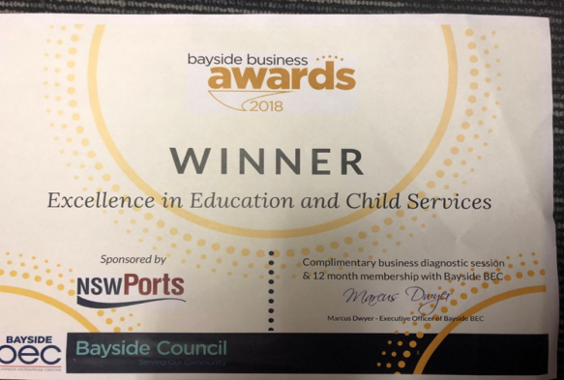
SMOOSH is an award winning not for profit community based service that provides quality Before/After and Vacation Care programs for school aged children.
SMOOSH Mobile number: 0431427176

