Bankstown South Infants School
Expression of Interest Application
Safe Multicultural Out Of School Hours (SMOOSH)

BSC: 6.30am to 9.00am: Fee $12 for the permanent session of 2.5 hours
ASC: 2.45am to 7.00pm: Fee $18 for the permanent session of 4.15 hours
Vacation care: 6.30am to 7.00pm: Fee $46 (plus cost of excursion/activity) for 11.5 hours
The fees above are full fees (before the application of the Child Care Subsidy).
This form indicates you are interested in your child/ren attending SMOOSH at Bankstown South Infants School in 2019.
Email it to smoosh@bsis.secc.sydney, or in person to SMOOSH staff or the Bankstown South Infants Public School office. Once the form has been received, SMOOSH will contact your family directly, providing further information about the service and how to formally enrol.
Further information is also available at www.secc.sydney.
If you wish to enrol officially, head to bit.ly/smooshform.

Child’s surname

Child’s first name

Male/ female

Date of birth/ age | DOB - Age -
Before-school care required  (Please circle) | Monday Tuesday Wednesday Thursday Friday
After-school care required  (Please circle) | Monday Tuesday Wednesday Thursday Friday
Casual care only required  (Please circle) | Yes/ No
Vacation care required | Yes/ No
Child’s expected start date

Contact details of person who completed this form | Name:  Contact phone number:  Email:

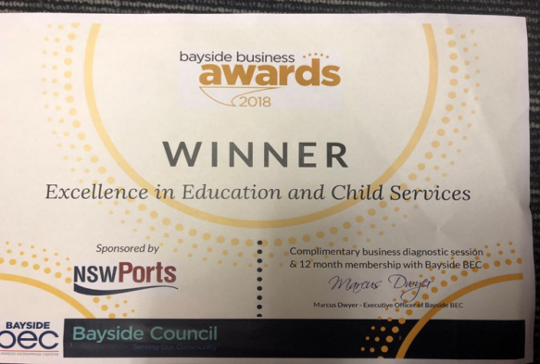
SMOOSH is an award-winning not for profit community based service that provides quality Before/After and Vacation Care programs for school-aged children.
SMOOSH mobile numbers: 0431 452 311/ 0431 427 176

