Expression of interest application
Safe Multicultural Out Of School Hours (SMOOSH)

BSC: 7.00am to 9.00am: Fee $12 for the permanent session of 2 hours
(Including breakfast)
ASC: 3.00pm to 6.00pm: Fee $18 for the permanent session of 3 hours
(Including afternoon tea and homework help)
VC: 7.00am to 7.00pm: Fee $46 (plus cost of excursion activity) for 11 hours

The fees above are full fees (before the application of the Child Care Subsidy).

If you are entitled to 85% Child Care Subsidy you would pay only $3.46 for an afternoon, $2.31 for the morning and $8.90 for Vacation Care.

This form indicates you are interested in your child/ren attending SMOOSH at Bankstown in 2019.
Email it to smoosh_bps@secc.sydney
Once this form has been received, SMOOSH will contact you with more information.
Further information is also available at bit.ly/smooshinfo
If you wish to enrol online, head to bit.ly/smooshform
Child’s surname

Child’s first Name

Male/ female

Date of birth/ age | DOB - Age-
Before-school care required  (Please circle) | Monday Tuesday Wednesday Thursday Friday
After-school care required  (Please circle) | Monday Tuesday Wednesday Thursday Friday
Casual care only required  (Please circle) | Yes/ No
Vacation care required | Yes/ No
Child’s expected start date

Contact details of person who completed this form | Name:  Contact phone number:  Email:

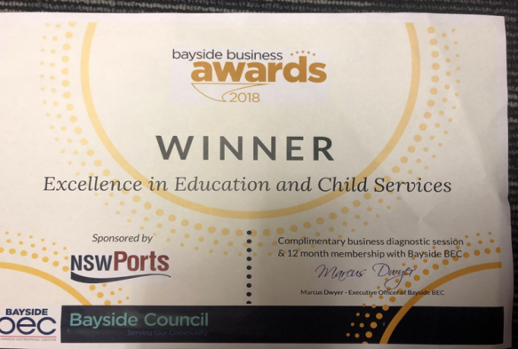
SMOOSH is an award winning not for profit community based service that provides quality Before/After School and Vacation Care programs for school aged children.
SMOOSH Mobile number 0415 783 446

